Who Is Interviewing You Form

Use this sheet to record all of the information you can find about the people who will be interviewing you. You can use the company’s website, social media sites like LinkedIn, people’s e-mail signatures, publications, articles and interviews to find this information. I also find that adding a photo is really helpful as it builds a level of familiarity with the individuals.

I’ve filled in the first line as an example.

Name | Photo | Job Title | Other Information
Susan Thomson | 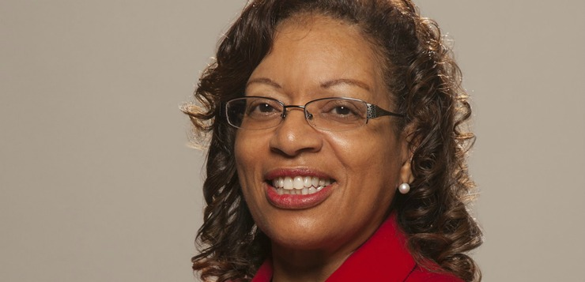 | Sales & Marketing Manager | - She has worked at the company for 3 years.  - She grew up in Manchester.  - She went to university in Leeds where she studied Economics - useful to drop into conversation my interest in economics  - She did a post graduate degree in marketing  - She previously worked at Next Clothing – I worked there while I was at university  - She has a young family and works four days a week – might make her more understanding of my need to work flexibly to do the school run  - She is a member of a professional women group
Add person 2
Add person 3
Add person 4

